Which of the following substance show the greatest increase in solubility as temperature increases?
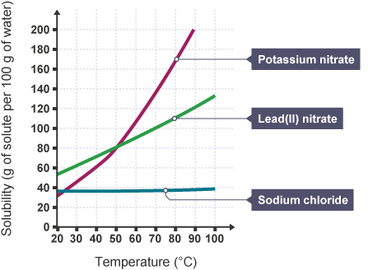
A. $KNO_{3}$
B. $Pb{\left(NO_{3}\right)}_{2}$
C. $NaCl$
D. All of these
ANSWER: A
Which substance is more soluble even at low temperatures, answer with the help of graph? 
A. $KNO_{3}$
B. $Pb{\left(NO_{3}\right)}_{2}$
C. $NaCl$
D. Both A & B
ANSWER: D
Which of the following substance show decrease in solubility with increase in temperature? 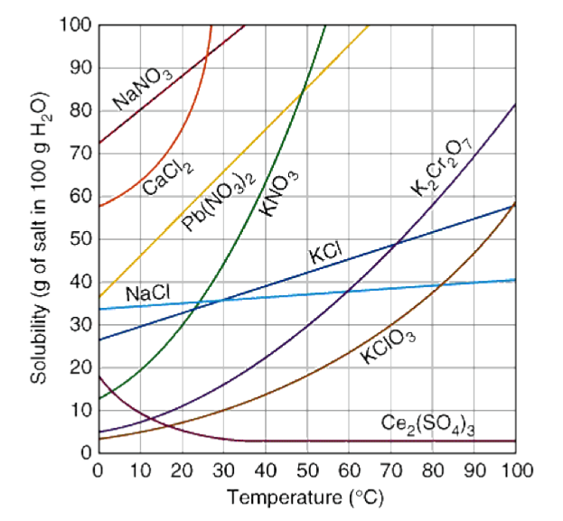
A. $KNO_{3}$
B. $Ce_{2}{\left(SO_{4}\right)}_{3}$
C. $NaCl$
D. $KCl$
ANSWER: B

It has relatively constant solubility with an increasing temperature.
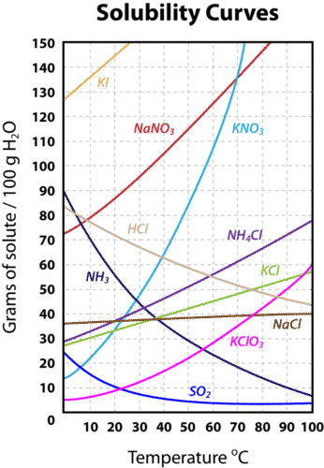
A. $KNO_{3}$
B. $Ce_{2}{\left(SO_{4}\right)}_{3}$
C. $NaCl$
D. $KCl$
ANSWER: C

At this temperature, sodium chloride and potassium nitrate solubility are the same.

A. $30℃$
B. $55℃$
C. $23℃$
D. $60℃$
ANSWER: C
Among the following, which substance will be dissolved in $C_{6}H_{6}$?
A. $AgCl$
B. $H_{2}O$
C. $NH_{4}OH$
D. Wax
ANSWER: D

Which solvent will help NaCl to dissolve in it?
A. $H_{2}O$
B. $CH_{3}OH$
C. $C_{6}H_{6}$
D. $CCl_{4}$
ANSWER: A

Which of the following pair is immiscible into each other?
A. $NaCl$ and $H_{2}O$
B. $CCl_{4}$ and $C_{6}H_{6}$
C. $CH_{3}OH$ and $H_{2}O$
D. None of these
ANSWER: D

The solubility of solids generally rises with
A. Increase in temperature
B. Decrease in temperature
C. Increase in the volume of the solvent
D. None of the above
ANSWER: A
When a large amount of solute dissolves in a given amount of solvent it forms
A. Concentration solution
B. Dilute solution
C. Aqueous solution
D. Saturated solution
ANSWER: D

Which of the following interaction cause solvation of ionic substance into polar solvent?
A. Dipole-Dipole interaction
B. London Dispersion force
C. Ion Dipole interaction
D. Hydrogen bonding
ANSWER: C
Which of the following is different in the process of dissolution of ionic and molecular specie?
A. Disruption of solute particles from the crystal lattice
B. Surrounding of solute particles by solvent
C. Heat of solvation
D. None of these
ANSWER: C
Which of the following interaction cause solvation of molecular substance into polar solvent?
A. Dipole-Dipole interaction
B. London Dispersion force
C. Ion Dipole interaction
D. Hydrogen bonding
E. Except option C
ANSWER: E
The process in which solvent molecules interact and surround solute ions or molecules is known as:
A. Solvation
B. Hydrolysis
C. Hydration
D. All of these
ANSWER: A
It breaks while the formation of solution.
A. Solute – solute interaction
B. Solute – solvent interaction
C. Solvent – solvent interaction
D. Both A & C
ANSWER: D
It helps to form while the formation of solution.
A. Solute – solute interaction
B. Solute – solvent interaction
C. Solvent – solvent interaction
D. Both B & C
ANSWER: B

Which of the following interaction broke by endothermic process?
A. Solute – solute interaction
B. Solute – solvent interaction
C. Solvent – solvent interaction
D. Both A & C
ANSWER: D
In which of the following interaction energy is released?
A. Solute – solute interaction
B. Solute – solvent interaction
C. Solvent – solvent interaction
D. Both A & C
ANSWER: B

